**SIMULATION OF Type-I PLL**

**Circuit Diagram:**

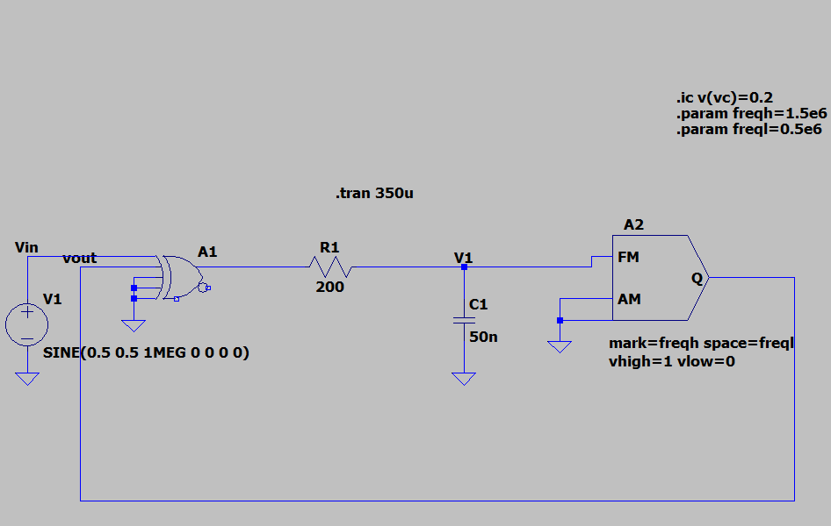

**Output: (FFT of Vout)**

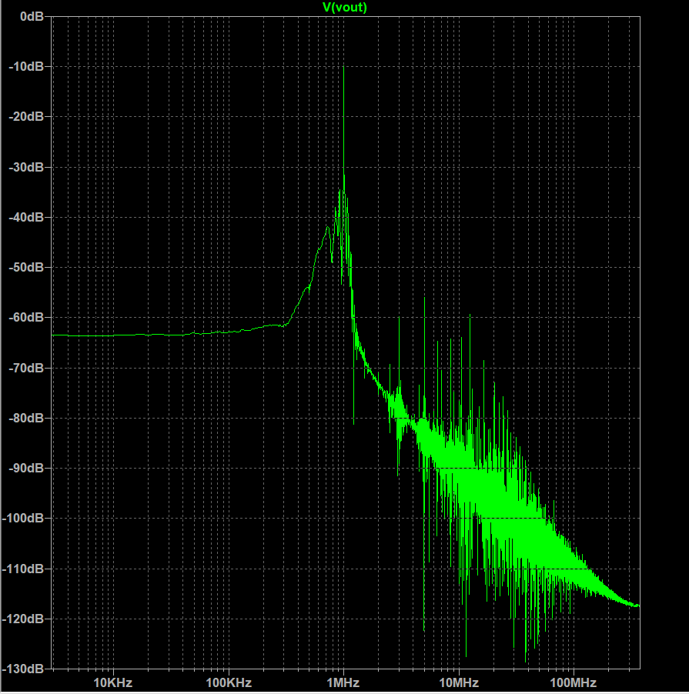

**Output of Vcont:**

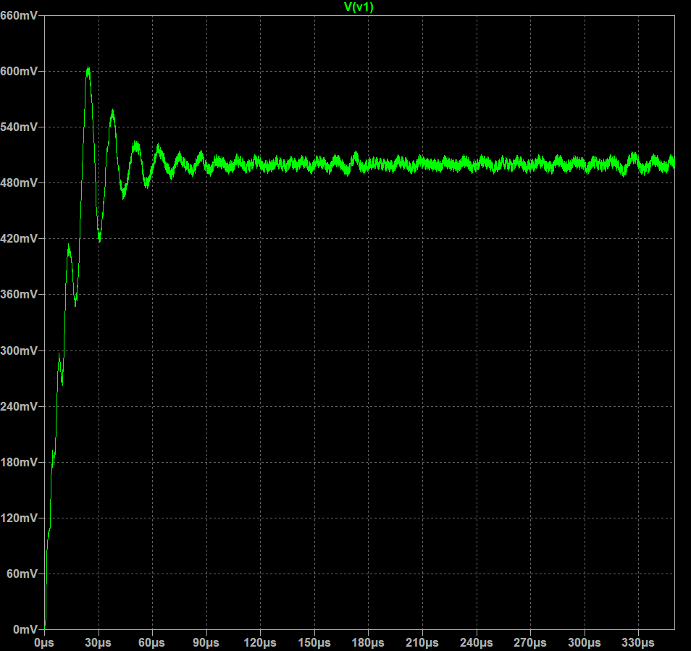

**Comparison of Vin and Vout:**

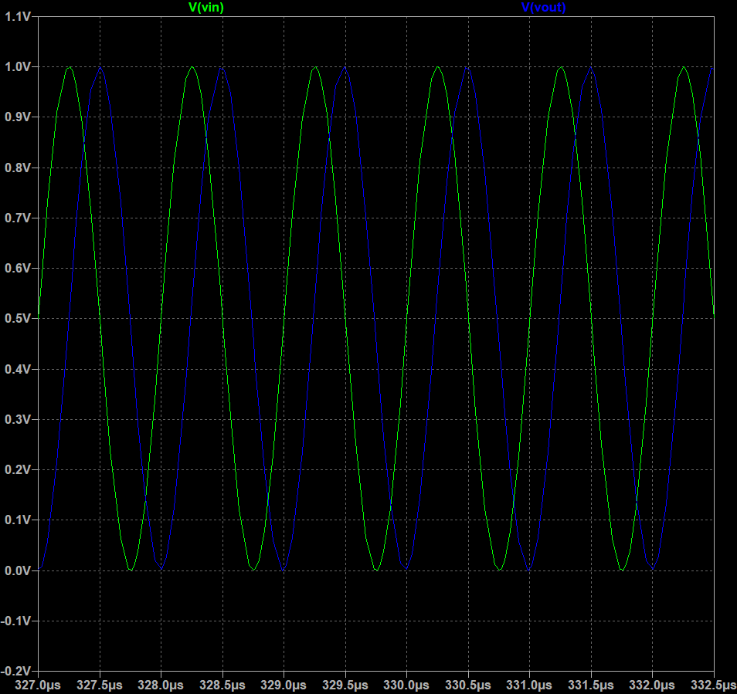

**Validation of PLL locked:**

